The Project Manager's Companion  Are You Running an Excuse Factory? |   VPMWORKS.COM

Are You Running an Excuse Factory?
The Project Manager's Companion · Issue No. ___
"Most waste comes from good people trying to do the right thing." — Jeffrey Liker

Walk past a struggling project at almost any company and you will hear the same soundtrack:
"I didn't know that was blocking me."
"We're a little behind, but we'll recover next sprint."
"That's not in my lane — engineering owns that one."
Three different teams. Three different industries. The same script.
When you hear the same lines from people who have never met, you are not listening to individual failures of character. You are listening to a system — a system that is reliably manufacturing excuses, day after day, and shipping them on time.
Most projects start as detailed plans but become excuse factories in disguise. They begin as schedules. They behave like alibis.
The good news: an excuse factory is a system, and systems can be retooled. Visual Project Management is one such retooling. Two principles do most of the work — accountability (every commitment has one owner who agreed to it) and visual management (every commitment is visible to the team in real time).
Here are three excuses I hear constantly, the system that produces each one, and what changes when you swap the system out.

Excuse 1 — "I didn't know it was waiting on me."
What the system is doing. A 200-row Gantt chart treats every task identically. The minor admin step and the cross-functional handoff get the same gray bar. The handoff — the moment work crosses from one function to the next, where 80% of the schedule risk lives — is almost invisible.
Of course people miss it. The chart was designed to hide it.
What VPM does differently. The plan is drawn as swim lanes, one per function. Tasks live inside a lane, and reach across only at handoffs. The handoff is no longer a gray bar — it is a numbered chevron passed from one lane to the next, the most visually prominent thing on the page. (See: Swimlane Diagram)
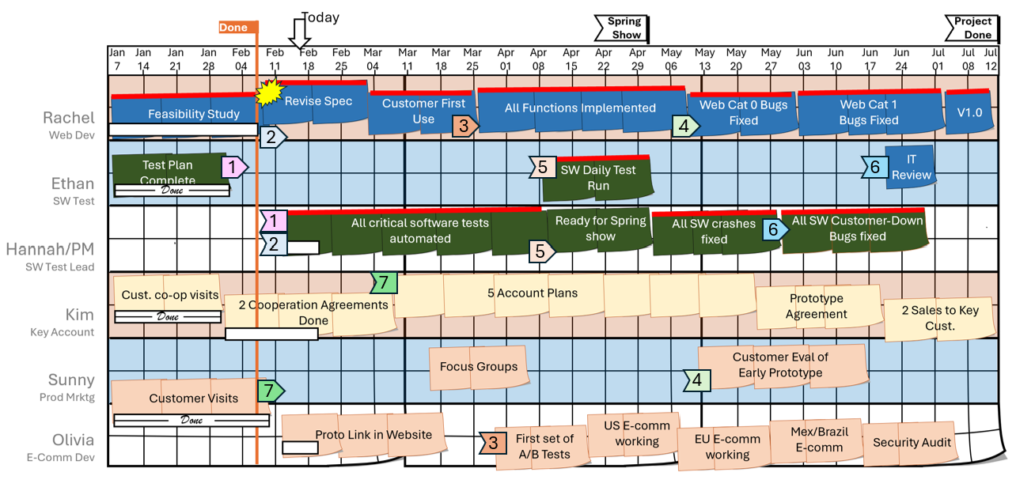
handoffs become the visual anchors of the plan
What disappears. "I didn't know" stops being a defensible answer. The handoff was on the chart, walked through in the daily stand-up — named, dated, and owned. Everyone in the room saw it. Accountability is not a speech the PM gives — it is a property of the diagram.

Excuse 2 — "We're a little behind, but we'll recover."
What the system is doing. The plan has no buffer. Or worse: it has buffer, but the buffer is hidden inside individual task estimates ("I'll say three weeks to be safe"), so nobody knows when the project is actually in trouble. Drift is invisible until the day someone admits the launch date is gone.
By then, every good recovery option is gone too.
What VPM does differently. Buffer is segregated from the schedule, sized by team consensus, and tracked on a single chart — the fever chart. Green, yellow, red. Everyone reads it the same way. (See: Buffer Methodology)
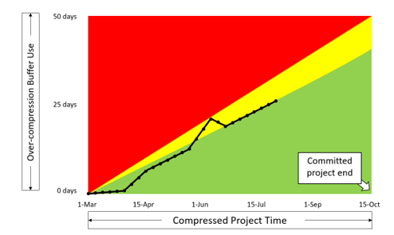
the team's shared scoreboard for schedule health
When the dot crosses from green to yellow, the team triggers Stop-Fix: stop, converge, name the obstacle, commit to one corrective action, name an owner, set a recovery date. Within the day. Not next sprint.
What disappears. "We'll recover" stops being a tense. It is no longer a vague future — next sprint, soon, after the holiday — it becomes an immediate action: today's stand-up, today's owner, today's recovery date. Accountability is not a feeling; it is a chart that is the same color for everyone in the room, with the next move dated for tomorrow morning.

Excuse 3 — "That's not in my lane — engineering owns that one."
What the system is doing. The PM built the plan in a silo, then briefed the team. Nobody on the team agreed to the dates; they were informed of the dates. So when reality bites, the team has no shared ownership of the commit. They have a document somebody else wrote.
Finger pointing is the rational move. The plan never belonged to anyone in the room.
What VPM does differently. The plan is built in a planning event with the cross-functional core team in the room. The team negotiates the dates. The team commits to the dates. RACI is assigned task-by-task — Responsible, Accountable, Consulted, Informed — with no ambiguity about who owns what. (See: RACI Task Breakdown · Project Planning Event)
What disappears. "Not my lane" becomes a falsifiable claim — and because the lane is named on the chart with the team member's initials in it, the claim is almost always false on its face. Most of the time it never even gets spoken: a glance at the wall, a name in the box, and the excuse dissolves before it reaches the meeting. Accountability is not a culture-deck slogan — it is a name on a swim lane that the person whose name it is helped put there.

"But my team isn't ready for this."
If that thought just landed, sit with it for a minute. The team is rarely the obstacle. The discomfort is yours — and it is the right discomfort to feel, because you are about to take ownership of a system that has been quietly protecting everyone, including you, from being seen.
What waits on the other side is what every team actually wants under the excuses: a project that finishes, work that ships, and people who go home knowing what they did and that it mattered. Success, satisfaction, engagement. Tearing down the excuse factory does not punish the team — it returns the team to the work.
Three moves to get yourself comfortable enough to lead it:
- Dig into the delays. Trace the last three slips back to the handoff or buffer that swallowed them. You are not assigning blame; you are learning the shape of your factory.
- Notice the excuses out loud. When you hear "I didn't know," "we'll recover," or "not my lane" this week, write them down. Awareness is the first cut.
- Build consensus before you build the chart. Get the core team in a room and agree on one thing: the current way of working is producing excuses, and we want better. Everything else follows.
The team is ready when you are.

The pattern
Every excuse on the list above has the same structure:
"Something important was happening. I could not see it. I am not at fault."
The first two clauses are usually true. The third one stops being true the moment the team can see what they were missing.
Visual management is not about pretty posters. It is about collapsing the gap between what is happening and what the team can see, until the gap is so small, "I didn't know" is removed from team vocabulary.
When you do that — when the handoff has a lane, the buffer has a color, and the commit has a name — the excuse factory shuts down. What replaces it is not heroic accountability. It is something quieter and more durable: a team that cannot help but see what is happening, so that good people cannot help but act on it.
That's the deal. The system either manufactures excuses or it manufactures action. Pick which factory you want to run.

George Ellis — VPM Works · See your project. Solve problems faster.
Further reading on vpmworks.com:
- Theory of Operation — the foundation
- Swimlane Diagram — making handoffs visible
- Buffer Methodology — fever charts and Stop-Fix
- Creating Ownership and Accountability — how the planning event builds shared commitment

One question for the comments: What's the most common excuse you hear on your projects — and what is your system doing to produce it?

